CSO Lab 2: Combinational Circuit Design
Observation:
Half Adder
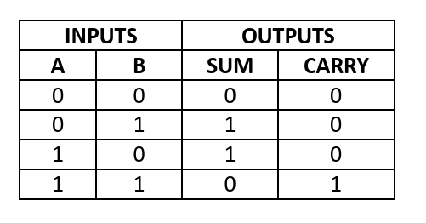

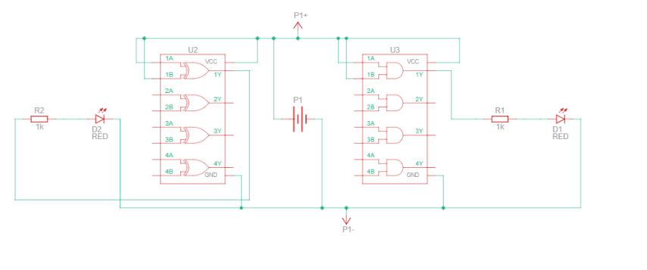
Schematic diagram
Input: A=0, B=1 Output: S=1,C=0
Input: A=0, B=0 Output: S=0, C=0
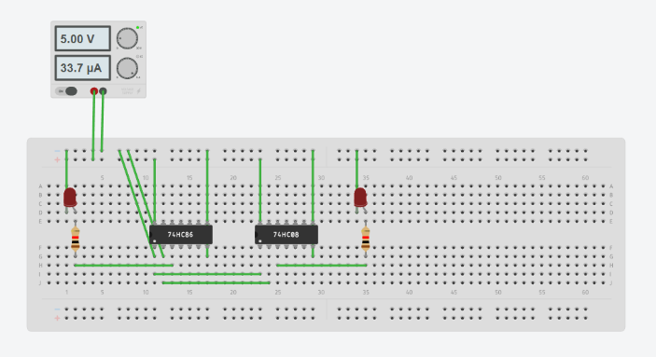
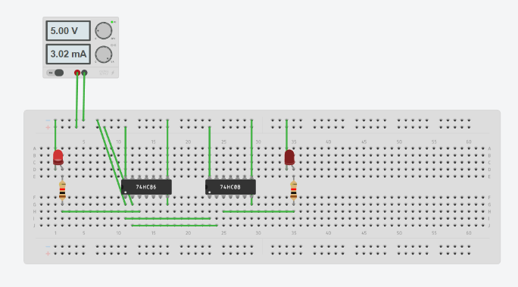

Input: A=1, B=0 Output: S=1,C=0
Input: A=1, B=1 Output: 1
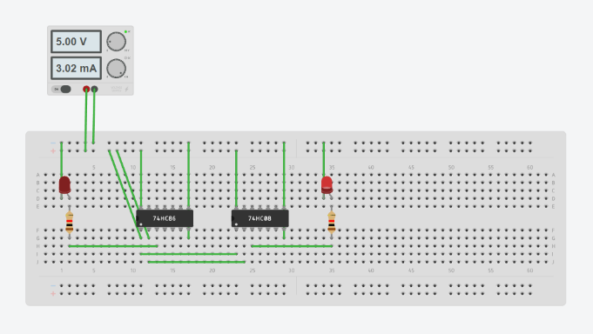
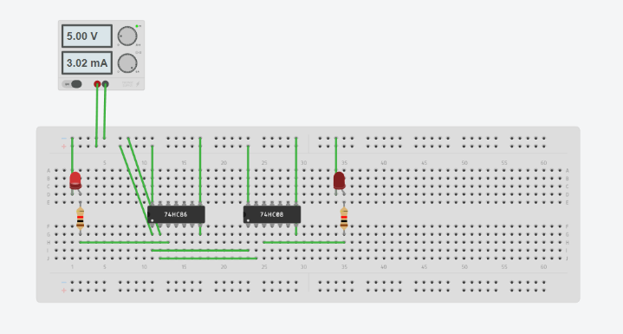

Full Adder
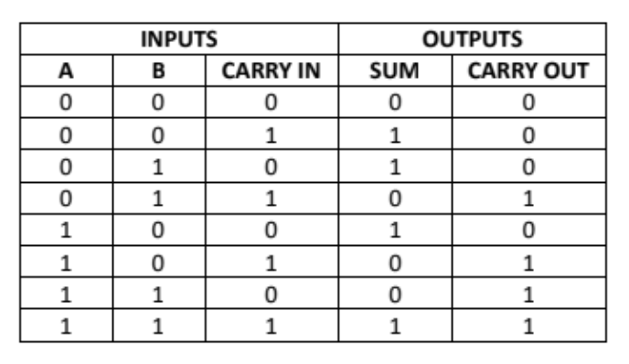
Schematic diagram
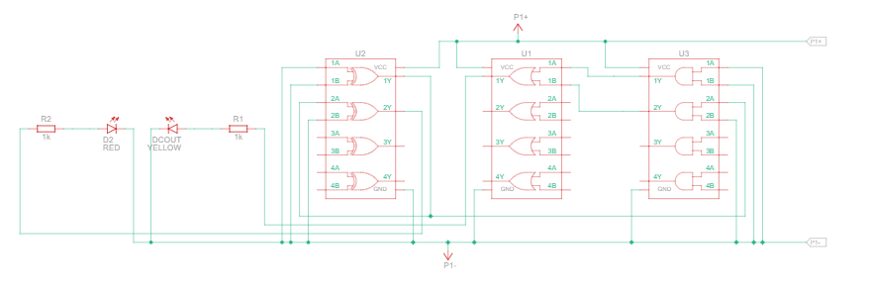

Input: A=0 B=0 Cin=1 Output: S=1, Cout=0
Input: A=0 B=0 Cin=0 Output: S=0, Cout=0
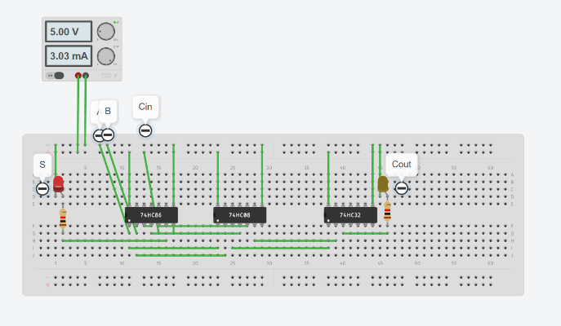
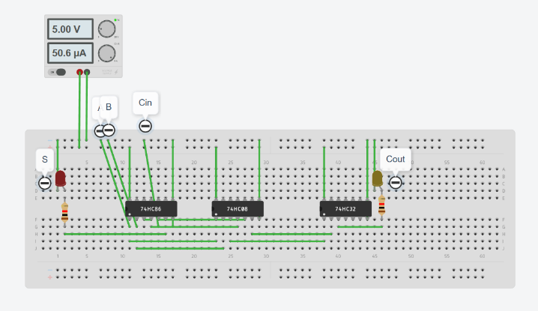

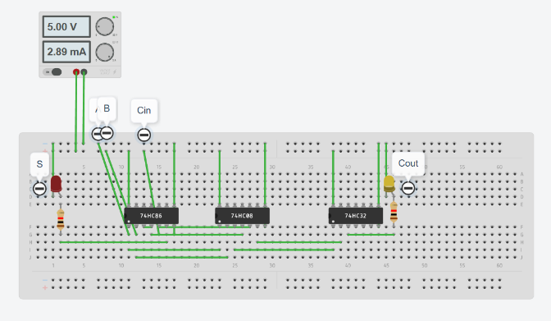
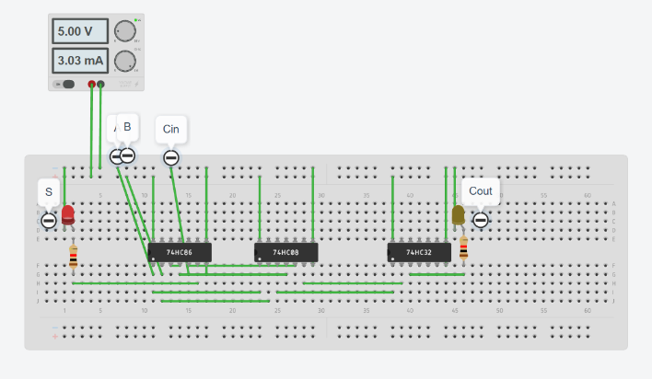
Input: A=0 B=1 Cin=1 Output: S=0, Cout=1
Input: A=0 B=1 Cin=0 Output: S=1, Cout=0

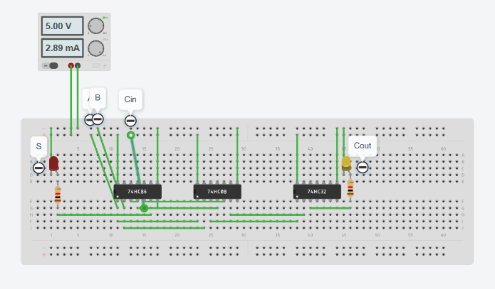
Input: A=1 B=0 Cin=1 Output: S=0, Cout=1
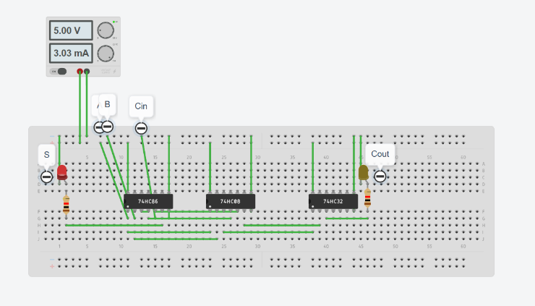
Input: A=1 B=0 Cin=0 Output: S=1, Cout=0

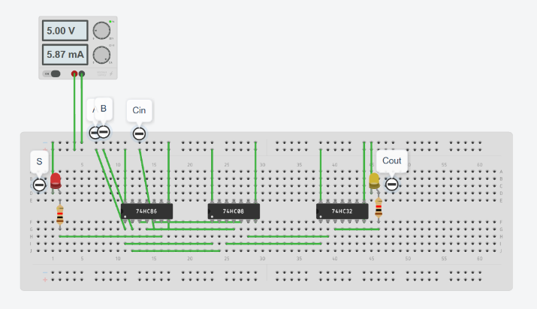
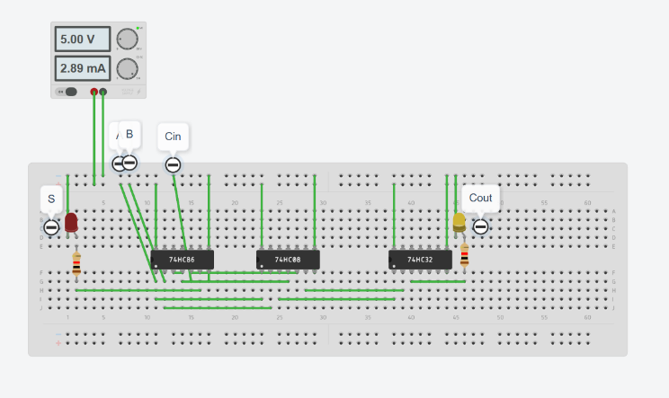
Input: A=1 B=1 Cin=1 Output: S=1, Cout=1
Input: A=1 B=1 Cin=0 Output: S=0, Cout=1

Result:
1.Half adder is made up of one XOR gate and one AND gate
2.Full adder is made up of two half adder and one OR gate.

